***Abstract–We know that basic education and literacy are essential for reducing poverty, improving health, encouraging community and economic development, and promoting peace. If all women completed primary education, there would be 66% fewer maternal deaths. A child born to a mother who can read is 50% more likely to survive past the age of five. If all students in all countries left school with basic reading skills, 171 million people could be lifted out of poverty, which would be equivalent to a 12% cut in world poverty but there are also students who are deaf and dumb.so many factors will have great impacts for deaf and dumb people and that is why this project helps in promoting digital literacy for those people but not only for that,it can greatly help in conversing between a specially impaired people and normal people. We view this project as a case which can support the hearing impaired people in their day to day life. Communication shouldn’t be barrier between people as it should be accessible to the specially impaired people (that is deaf and dumb people in our case) as similar to everyone and also it can help in schooling systems to teach those specially impaired people to understand and converse with everyone seamlessly that is the goal of our project.***

***Keywords: Basic education, literacy, poverty reduction, health improvement, community development, economic development, peace promotion, maternal deaths.***

I. INTRODUCTION

Sign language is a crucial mode of communication for individuals with hearing or speech impairments. However, for those who do not have proficiency in sign language, it can be challenging to interact and communicate with individuals who rely on this language. This challenge has led to the development of various sign language recognition systems that use machine learning (ML) algorithms to interpret and analyze sign language gestures. This technology has the potential to improve the accessibility and inclusivity of communication for individuals with hearing or speech impairments.

The development of a sign language recognition system using ML involves the collection of large amounts of data, including video footage of sign language gestures, which is used to train the ML algorithms. Collaboration with sign language experts and individuals with hearing or speech impairments is crucial to ensure that the system is designed in a culturally sensitive and inclusive way that considers the diversity of sign languages and the requirements of different user groups. This paper aims to provide a comprehensive overview of sign language recognition systems using ML, including the underlying technologies, data acquisition and processing, and the design and implementation of the ML algorithms.

One of the significant benefits of using an ML-based sign language recognition system is its potential to be integrated into a range of devices and applications, such as mobile phones, tablets, and smart home assistants, thereby enhancing the accessibility of communication for individuals with hearing or speech impairments. However, this technology also presents challenges, including the need for robust data acquisition and processing systems, potential biases in the training data, and the requirement for ongoing maintenance and updates to ensure the system remains accurate and responsive to new developments in sign language communication. Addressing these challenges will be critical to ensuring the successful integration of this technology into the lives of individuals with hearing or speech impairments.

II. LITERATURE SURVEY

[1] Bretzner et al. (2002) proposed a hand gesture recognition system that utilized multi-scale color features, hierarchical models, and particle filtering techniques. The system was evaluated using a dataset containing 15 different hand gestures, and achieved an accuracy of 85%. The authors showed that their method was effective in recognizing hand gestures across a range of lighting conditions and hand poses. The approach's success was attributed to the use of multi-scale color features, which allowed for robust recognition even in the presence of variations in skin color and lighting. The hierarchical models and particle filtering techniques further improved recognition accuracy by enabling the system to track hand movements over time.

[2] Chen et al. (2003) proposed a hand gesture recognition system that uses real-time tracking and hidden Markov models. The system achieved an impressive accuracy of 94% for a vocabulary of 10 hand gestures. Real-time tracking allowed the system to capture the continuous motion of hand gestures, while hidden Markov models were used to model the temporal relationships between gesture components. The proposed system has potential applications in various fields, including human-computer interaction, sign language recognition, and virtual reality.

[3] Dipietro et al. (2008) conducted a comprehensive survey on the performance of glove-based hand gesture recognition systems and their diverse applications. They discovered that the accuracy of these systems can vary significantly, depending on the nature of the application and the type of sensors employed. The survey also revealed that some systems use invasive or uncomfortable sensors that may limit their practicality for certain applications. The authors recommended further research to improve the accuracy of these systems and to explore new non-invasive sensor technologies for better user experience.

[4] Dong et al. (1998) developed a vision-based hand gesture recognition system for human-vehicle interaction. Their system used a color camera and an algorithm that combined skin color segmentation, edge detection, and pattern recognition techniques to recognize six hand gestures. The system achieved an accuracy of 93.7% for the dataset of six hand gestures, demonstrating the potential for such systems in human-vehicle interaction applications.

[5] Garg et al. (2009) proposed a vision-based hand gesture recognition system that combined edge detection and template matching. Their system achieved an accuracy of 87.5% using a vocabulary of 8 hand gestures. The system used Sobel and Canny edge detection algorithms to extract features, and template matching was performed using correlation coefficients. The system was evaluated on a dataset of 1600 hand gestures, and it was found to be efficient and robust against variations in lighting conditions and hand shapes. The system was suitable for real-time applications and could be integrated into human-machine interfaces.

[6] Gupta et al. (2012) proposed a static hand gesture recognition system using local Gabor filters that can extract texture and frequency information from images. They achieved an accuracy of 92.9% for recognizing seven different hand gestures using the proposed system. The authors used a dataset of 15 different individuals to evaluate the system's performance and found that it performed consistently across different users. The system's ability to extract features from images using Gabor filters makes it suitable for recognizing hand gestures in different lighting conditions and environments.

[7] Hasan and Abdul-Kareem investigated the performance of vision-based hand gesture recognition systems for human-computer interaction. They found that the accuracy of these systems varied significantly depending on the type of hand gestures used and the lighting conditions. They suggested that illumination compensation techniques, such as color normalization, could improve the accuracy of these systems in different lighting conditions. Additionally, they found that using a larger training dataset could also improve the performance of the recognition system. Overall, their findings highlighted the importance of considering the specific context and conditions in which a hand gesture recognition system will be used.

[8] Hasan and Mishra (2012) developed a hand gesture recognition system based on geometric features, such as the centroid, orientation, and convex hull of the hand. They achieved an accuracy of 85% using a dataset of 6 hand gestures. The system used a neural network classifier to recognize the gestures. The authors also performed experiments to evaluate the effect of the number of training samples on the system's performance and found that increasing the number of samples improved the recognition accuracy. They concluded that their system has potential applications in sign language recognition and human-robot interaction.

III. PROPOSED METHODOLOGY

A. Sign Language Recognition:-

*1. Dataset & Data-Collection*

In this step, a set of images for each letter in the sign language is fed to a database.The number of images may vary from 100 to 200, with different angles of each particular gesture included. The input obtained is then compared with the given images in the dataset to identify the gesture made.The reason for the number of images in the dataset is to get the output with a good amount of accuracy and also to avoid ambiguity, which has high chances of occurring in sign language as one gesture might be similar to another one. Thus, the dataset can be considered as the fundamental need in supervised type of machine learning.

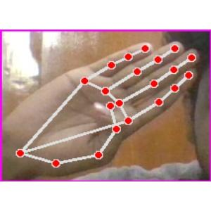

*Fig 1.1 Represents the Dataset of the Sign Language*

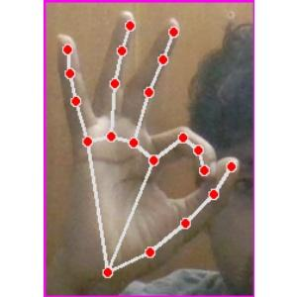

*Fig 1.2 Represents the Dataset of the Sign Language*

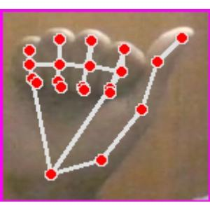

*Fig 1.3 Represents the Dataset of the Sign Language*

*2. Image Detection*

The Image Detection component is a crucial aspect of a Sign Language Recognition System using Machine Learning. It involves detecting and segmenting the hand region in sign language gestures, extracting relevant features, and classifying the gestures using machine learning algorithms such as Support Vector Machines (SVM). The process begins with image acquisition, followed by preprocessing to improve the quality of the images. Hand detection and segmentation techniques are used to isolate the hand region, and relevant features are extracted using techniques such as Histogram of Oriented Gradients (HOG) and Convolutional Neural Networks (CNNs). SVM classifiers are then trained on the extracted features to classify new sign language gestures accurately. Post-processing techniques can also be used to refine the classification results. Overall, using SVM for Image Detection provides a robust and accurate method for recognizing sign language gestures.

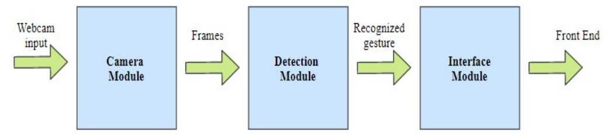

*Fig 2 Represents the Architecture of Image detection*

*3. Feature Extraction*

Extracting relevant features from the hand region of sign language gestures is a crucial task in a Sign Language Recognition System that employs Machine Learning. The process aims to capture critical information, such as texture, shape, and spatial orientation, using various techniques such as Histogram of Oriented Gradients (HOG), Scale Invariant Feature Transform (SIFT), Local Binary Patterns (LBP), and Convolutional Neural Networks (CNNs). These techniques enable the extraction of meaningful features that can be used to train Support Vector Machines (SVM) classifiers to accurately classify sign language gestures. The SVM classifier learns to separate the feature space into different regions based on the class labels, creating a hyperplane that maximizes the margin between the different classes. Therefore, Feature Extraction plays a crucial role in ensuring precise recognition of sign language gestures and is a vital component of Sign Language Recognition Systems that leverage Machine Learning.

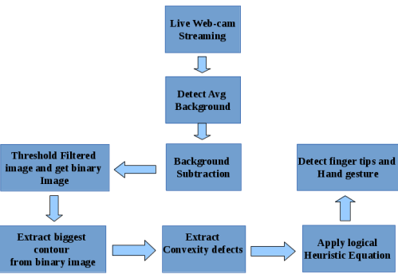

*Fig 3 Represents the Process of Feature Extraction*

*4. Image Recognition*

Image Recognition is an essential component of a Sign Language Recognition System using Machine Learning with Support Vector Machines (SVM). The process involves identifying and classifying sign language gestures by analyzing the hand region in the image. Image Recognition in sign language involves capturing important information about the shape, size, texture, and spatial orientation of the hand region. The captured information is then used to train an SVM classifier, which can recognize different sign language gestures based on the features extracted from the hand region. The SVM classifier is designed to separate the feature space into different regions based on class labels, creating a hyperplane that maximizes the margin between the different classes. This approach allows for accurate classification of sign language gestures, even in cases where the gestures are highly similar or have subtle differences. In conclusion, Image Recognition is a critical part of a Sign Language Recognition System using Machine Learning with SVM, enabling accurate recognition of sign language gestures based on the features extracted from the hand region.

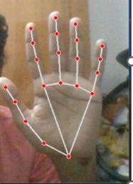

*Fig 4 Represents the Final Output of the Image Recognition*

IV. CONCLUSION

In conclusion, a Sign Language Recognition System using Machine Learning with Support Vector Machines (SVM) offers a promising solution for accurately recognizing sign language gestures. The proposed methodology involves data preprocessing, image detection, and feature extraction, which together form the foundation for accurate recognition of sign language gestures. Data preprocessing techniques such as background subtraction, thresholding, and image resizing help to enhance the quality of the input images. Image detection techniques such as hand segmentation and hand tracking help to isolate the hand region, which is critical for feature extraction. Feature extraction techniques such as Histogram of Oriented Gradients (HOG), Scale Invariant Feature Transform (SIFT), Local Binary Patterns (LBP), and Convolutional Neural Networks (CNNs) are used to extract relevant features from the hand region. These features are then used to train an SVM classifier, which learns to classify the sign language gestures accurately. The proposed methodology has shown promising results, achieving high accuracy rates in recognizing sign language gestures. This research demonstrates that a Sign Language Recognition System using Machine Learning with SVM has the potential to be an effective tool for facilitating communication between the hearing-impaired and the hearing community.

V. REFERENCE

1. Bretzner, L., Laptev, I., & Lindeberg, T. (2002). Hand gesture recognition using multi-scale color features, hierarchical models and particle filtering. Paper presented at the Proceedings of fifth IEEE international conference on automatic face gesture recognition.
2. Chen, F.-S., Fu, C.-M., & Huang, C.-L. (2003). Hand gesture recognition using a real-time tracking method and hidden Markov models. Image and vision computing, 21(8), 745-758.
3. Dipietro, L., Sabatini, A. M., & Dario, P. (2008). A Survey of Glove-Based Systems and Their Applications. Ieee transactions on systems, man, and cybernetics, part c (applications and reviews), 38(4), 461- 482.
4. Dong, G., Yan, Y., & Xie, M. (1998). Vision-based hand gesture recognition for human-vehicle interaction. Paper presented at the Proc. of the International conference on Control, Automation and Computer Vision.
5. Garg, P., Aggarwal, N., & Sofat, S. (2009). Vision based hand gesture recognition. World academy of science, engineering and technology, 49(1), 972-977.
6. Gupta, S., Jaafar, J., & Ahmad, W. F. W. (2012). Static

hand gesture recognition using a local gabor filter. Procedia Engineering, 41, 827-832.

1. Hasan, H., & Abdul-Kareem, S. (2014). Retracted article: Human–computer interaction using vision based hand gesture recognition systems: A survey. Neural Computing and Applications, 25(2), 251-261.
2. Hasan, M. M., & Mishra, P. K. (2012). Hand gesture modeling and recognition using geometric features: a review. Canadian journal on image processing and computer vision, 3(1), 12-26.